Ringing without touching the button

Description:
Let your visitors make contactless call, without pressing any button by simply waving before your intercom:

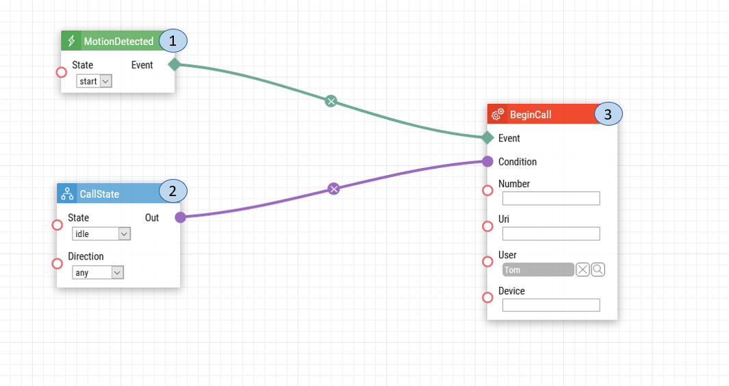
- Motion Detected. Once the intercom's camera detects motion, a start signal is sent to the devices to begin a call.
- Call State. The Call State will make sure that the intercom automatically calls all the devices only if there is motion detected.
- Begin Call. Once motion is detected, the user will be called from the intercom. The device can be called either by a telephone number, IP address, user or device ID.

Intercom Camera Configuration:

If you have not configured the internal intercom camera for motion detection, please follow the steps below.

Steps for configuration:
1. Upon login select Hardware setting.
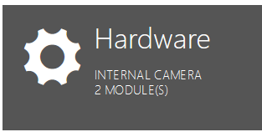
2. Choose the Camera option on the left-hand menu.
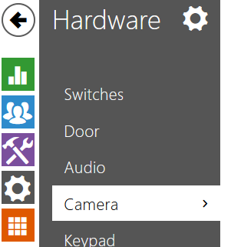

3. Choose the Internal Camera tab at the top of the page.
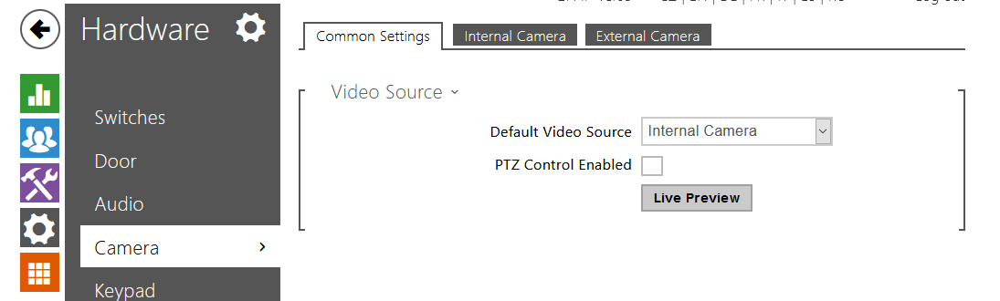

4. For the internal camera, enable Motion Detection and select the area of the picture where the motion shall be detected by the camera. Please ensure to click Save at the bottom.
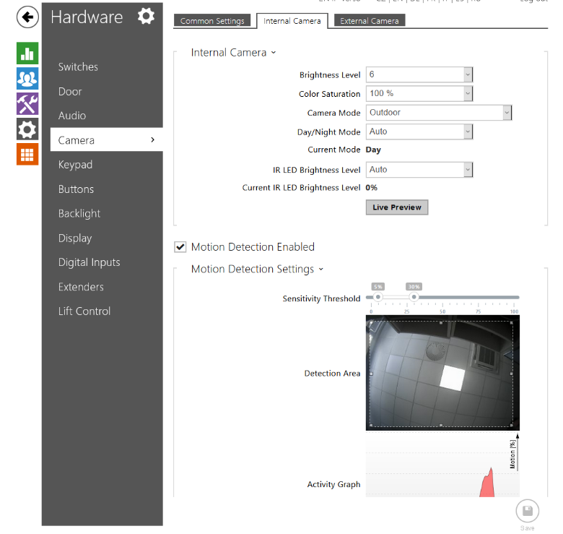

Date of automation design: 07/17/2020

Firmware Version: 2.29.1.38.8

List of compatible Hardware:
- 2N IP Verso
- 2N IP Solo
- 2N IP Vario
- 2N IP Base
- 2N IP Force
- 2N LTE Verso

List of adjustable user credentials:
- Users

List of automation parameters:
- State
- Direction
- Telephone number
- Device ID (ID can be found in the LAN call settings)
- Uri (IP Address)
- User
Requirements:
- 2N Intercom with camera
- 2N Enhanced Integration and 2N Enhanced video license (or Gold license) *Not applicable to the USA

