An intercom as part of a smart home

Description:
When you come home, the lights turn on once you unlock your door, after sundown and before sunrise. If you have smart lighting, then the lighting turns on with your favourite colour light appear and music to play upon entering the home.

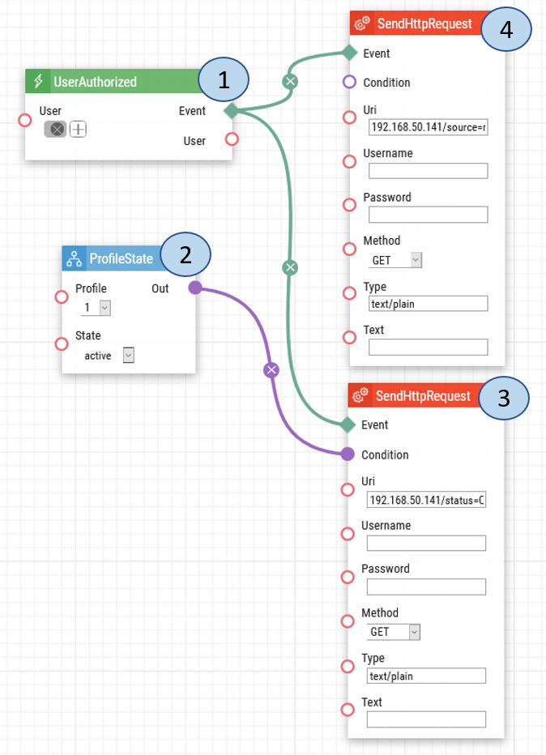

Description of Automation:
- User Authorized. Once a user enters their user credentials, an HTTP request is sent to the lighting system to turn on the lighting and second HTTP request to play the music.
- Profile State. Will set the lighting to only turn on based on the Time Profile set for the user.
- Send HTTP Request. Once the users enter their home and it is within the Time Profile, an HTTP request will be sent to the lighting system to turn on the lighting*.
- Send HTTP Request. Once the users enter their home, an HTTP request will be sent to the lighting system to play the music*.

* Note: The Uri for this automation will depend on the lighting systems, along with the home networking settings. Please consult the manufacture of the lighting system for the correct Uri.

Intercom User Configuration:
If you have already users created and their time profiles set, you may skip this portion and start using the automation. Otherwise, if you have not created users and their time profiles, please follow the steps below.

To set the timing for when the lights are to turn on, a time profile can be used however and adjusted. Below are the screenshots on how to configure the time profiles.

1. Once your login to the 2N IP Intercom chooses the Directory button on the home page.
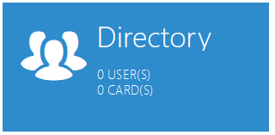
2. Create a User and then select their profile. 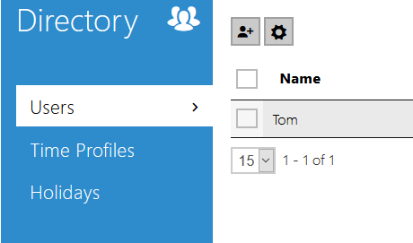

3. Choose Time Profile settings from the left-hand side settings menu.
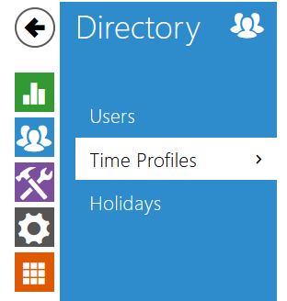

4. Set the time profiles for when you prefer the lights turn on and the radio to play. Click the Save button at the bottom once you are ready.

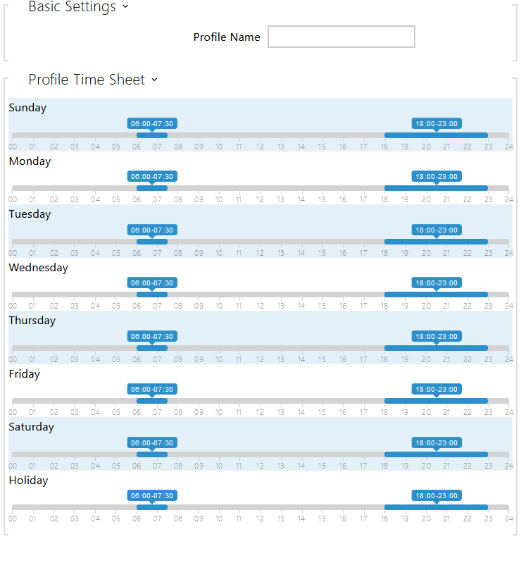
Date of automation design: 07/17/2020

Firmware Version: 2.29.1.38.8

List of compatible Hardware:
- 2N IP Intercoms – any intercom with automation and any possibility of entry credentials will work
- 2N Access Unit 2.0
- 2N Access Unit

For this scenario you can use the following credentials:
- Fobs / Cards
- Fingerprints
- Entry Codes / PINs
- Bluetooth
- NFC

List of automation parameters:
- User - the user who can switch on the light
- Profile – defines the time when an action is triggered
- Uri - must be change and support according to your system (check your device manual)
  - Username
  - Password
  - Method
  - Type
  - Text

Requirement:
- 2N Intercom
- 2N Enhanced Integration (or Gold license) *Not applicable to the USA

