Alarm if the door is open too long

Description:
Securing doors against leaving them opened too long.
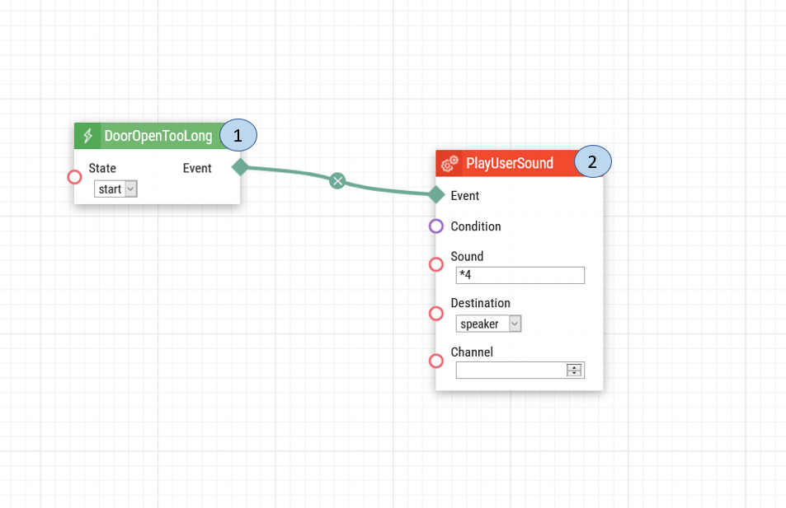
- Door Open Too Long. Once the Door Open Too Long sensor is triggered, a signal will be sent for sound to be played.
- Play User Sound. When the signal is received, the sound chosen to be played will be heard.

Note: For the automation to work, the Door Open Detection needs to be enabled. The following steps will outline the process.

Intercom Door Configuration:
Enabling the Door Open Too Long functionality
1. Upon login select Hardware the setting.
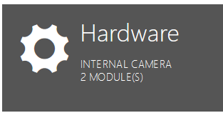

2. On the left-hand menu select the Door option.
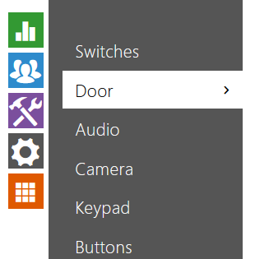

3. On the Door tab, enable the Door Open Too Long Detection. Below it, you can configure for how long the door can remain open. Make sure that the assigned input is set to the correct input. Click Save once you are ready.

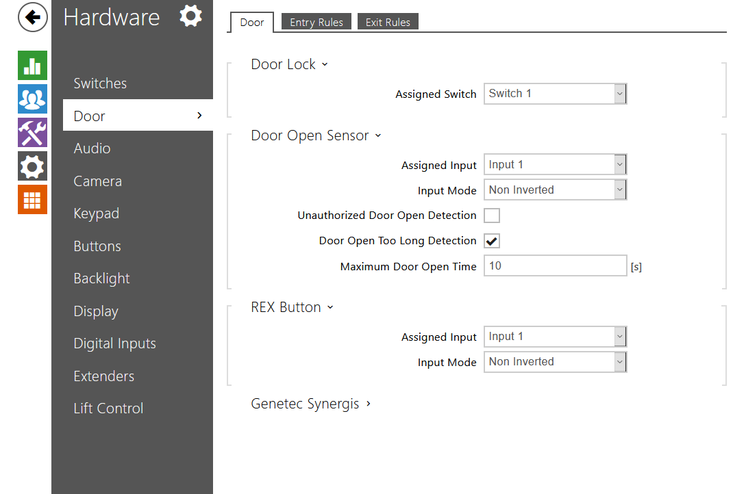

Note: The door contact must be connected to the IP Intercom for the Door Open Too Long to be detected. In this example it is connected to Input 1

Date of automation design: 07/17/2020

Firmware Version: 2.29.1.38.8

List of compatible Hardware:
- 2N IP Verso
- 2N IP Solo
- 2N IP Vario
- 2N IP Base
- 2N IP Force
- 2N IP Safety

List of automation parameters:
- Sound
- State
- Destination

Requirements:
- 2N Intercom
- 2N Enhanced Integration license (or Gold license) *Not applicable to the USA

